**Task -6**

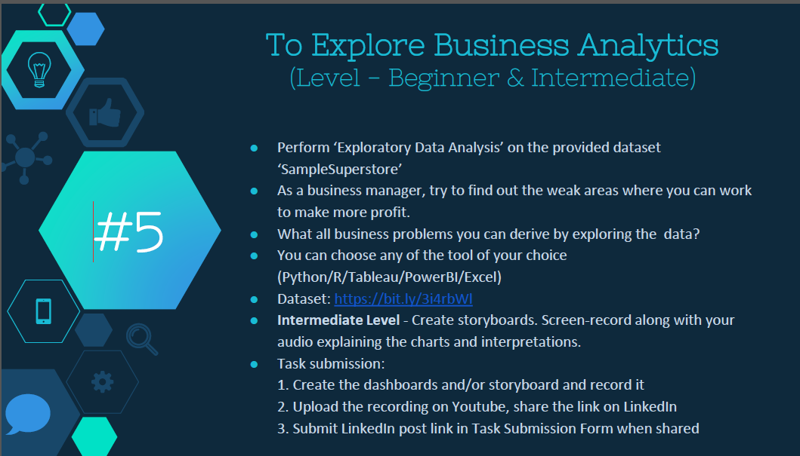

**Tableau Link -** [**https://public.tableau.com/profile/ashish.pareek#!/vizhome/AnalysisofSuperstoredataTask5/Dashboard3**](https://public.tableau.com/profile/ashish.pareek#!/vizhome/AnalysisofSuperstoredataTask5/Dashboard3)